**Saurin Shah**

**NUID: 001441797**

**Assignment 2**

Technology areas discussed below is based on Automation that focuses on systems integrating sensors and actuators that function semi-autonomously or autonomously in collaboration with humans:

1. **Machine learning**

- Machine learning allows software applications to become accurate in predicting outcomes. It’s an application of Artificial Intelligence.

- Day by day humans are getting more relying on machines. With aim of machine learning which is to allow computers to learn automatically without human intervention. It can be well predicted that machine learning is the future.

- Applications include web search engine, photo tagging applications, and spam detector, database mining for growth of automation, digital marketing, healthcare, and education.

- Not only analysts but also MNC or startups, any Internet user would benefit the most from machine learning. It simply can get better.

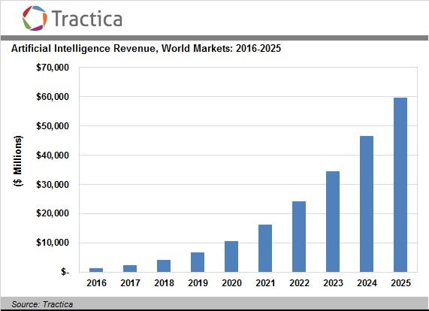

1. **3D Printing**

- 3D printing is a process of making three-dimensional solid objects from a digital file. Complex shapes can be manufactured using less material through 3D printing. Few advantages of 3D printing:

* + Additive process
  + Intricate shape
  + Ease of manufacturing
  + Ease of use
  + Reduced workforce and Training cost
  + No tooling, jigs and fixtures
  + Direct final object manufacturing

- Industries that will benefit the most from 3D printing are Aerospace, Automotive, Biomedical and Design of all kinds

- Setting the right nozzle height, leveling the bed and keeping up the right temperature would be an ideal practice before carrying out any type of 3D printing.

- Usual challenge of 3D printing is less productivity (production speed). It would be a major break though if anyway that productivity can be improved.

1. **Unmanned aerial vehicle (UAV)**

- Commonly known as drones is a type of unmanned vehicle and an aircraft without pilot on board.

- Drones are getting increasingly popular because it has very wide range of applications and use. It can be used for studying atmospheric research to disaster relief, and even zipping inside hurricanes to study the wild storms.

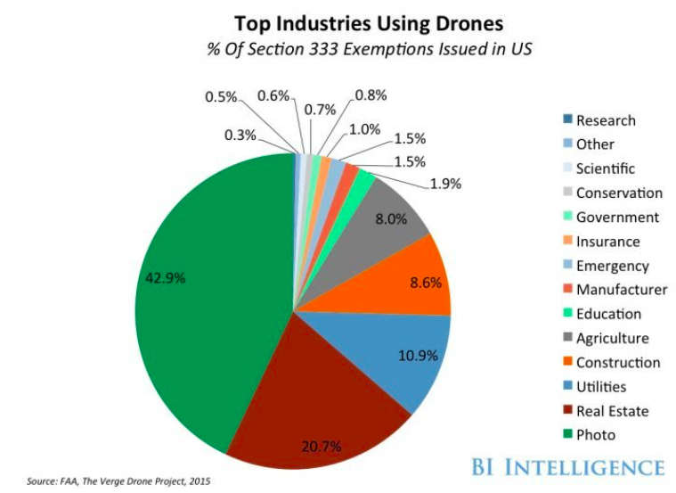

Ref: <https://www.businessinsider.in/tech/news/drone-technology-uses-and-applications-for-commercial-industrial-and-military-drones-in-2020-and-the-future/articleshow/72874958.cms>

- There are technologies that are being applied and developed within industry to help keep operations safe

- Parachutes - Geofencing

- Computer vision - Lighting

- DJI AirSense

1. **Autonomous Vehicle (AV)**

- It is simply a vehicle that is capable of sensing its environment and moving safely with little or no human input.

- Business Insider Intelligence reports that roughly 10 million cars with automated navigation technology will be on the road in 2020. McKinsey has predicted that roughly 15% of automobiles sold in 2030 could be fully autonomous.

- AV rely on sensors, actuators, complex algorithms, machine learning systems, and powerful processors to execute software.

1. **“Just Walk Out” Technology by Amazon Go**

- The core of the Amazon Go store is Computer Vision based Deep learning that is used to continuously track and estimate the intension of everyone in the store. In September 2018, Bloomberg News reported Amazon was considering plans to open as many as 3000 Amazon Go locations across the United States by 2021. Through this we can conclude that Amazon is taking offline store experience to a new level.

- There are 6 core top-level issues mainly focused for “Computer Vision Complete”:

- Calibration - Person detection

- Object Recognition - Pose estimation

- Activation Analysis - Sensor Fusion